Dennys Place Laneway Breakthrough
What We Heard Report
Overview
The Dennys Place Laneway Breakthrough project is one of the initiatives of the Revitalising Central Geelong (RCG) Action Plan. The project aims to improve the connectivity and permeability of central Geelong by creating intimate and unique laneways.
The exciting designs for the new laneways resulted from input from a range of precinct partners (traders, building owners and residents), stakeholders and interested community members.
Context
Since the beginning of the RCG Action Plan, the RCG Partnership has worked alongside stakeholders and the community to progress projects to/that? reflect the current needs and future uses, aligning each project’s outcomes with the vision for a thriving economy and vibrant city centre.

The Geelong City Deal has allocated $1.35 million towards the development of the new laneway connecting Malop Street to the Little Malop Street dining and service precinct. The Geelong City Deal builds on the State Government’s investment into project planning and the purchase of 28 Malop Street, Geelong.
Opportunity

The designs for the new laneway aim to respect the heritage character of the existing building and enhance the Traditional Owners’ cultural connection to central Geelong through the built form. There is also opportunity to resolve the long history of water management through the precinct and provide a design narrative on the importance of water in the urban setting.
Approach
Precinct partners, stakeholders, responsible authorities and the community were invited to participate in a series of design workshops in 2018 and value management workshops in 2021.

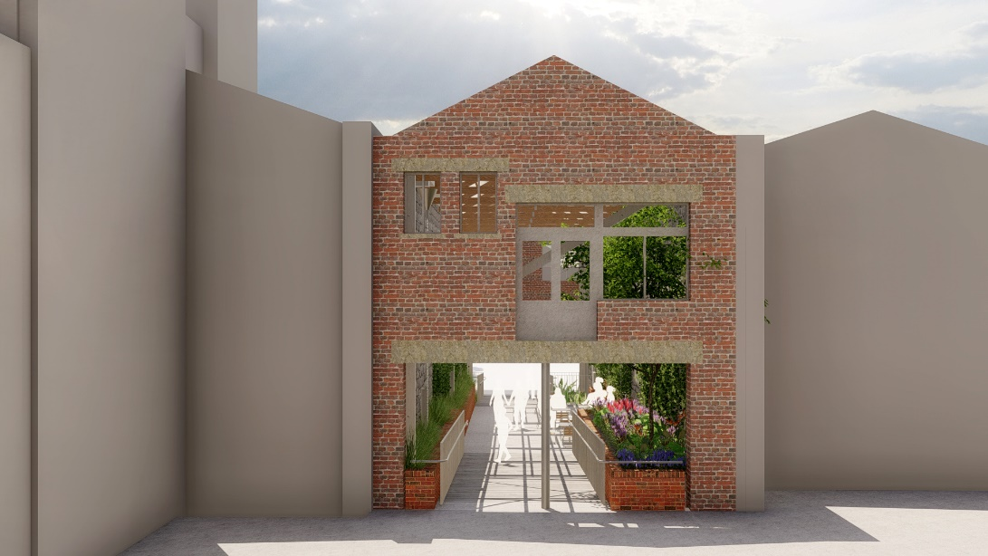
What We Heard Report – Summary Laneway design
- The heritage character of the existing building should be retained in some way to respect the Woolstores Heritage Area.
- The line of sight through the new breakthrough into Dennys Place should feel safe, welcoming and open.
- The name of the laneway does not have a positive connection to Wadawurrung people.
- Passive climate control should be provided through vegetation growth, wall treatments and open areas.
- Use the City of Greater Geelong Public Realm Framework to guide the materials palette and the design to encourage undisruptive passage of skateboarders.
- The design should integrate access of adjoining commercial ventures, if possible, to develop passive surveillance in conjunction with lighting strategies.
- The selection of plants should be hardy and include indigenous species where suited.
Water management
- The stormwater infrastructure through the laneway is important to the precinct to address water infiltration to building basements, re-use water where possible, and allow for cleaner water to enter the stormwater system.
- The maintenance of a proposed basement garden and upper story plants is being given due consideration.
- Consideration has been given to the integrity and maintenance of the proposed waterproofing membrane, the levels and the lifespan of materials used.
Operation of the laneway
- Dennys Place provides vehicle access to businesses and residential apartments, and is used for deliveries and services. Vehicle turning, manoeuvring, parking and gradient changes for a range of vehicle sizes is important to the designs.
- Vehicle access for deliveries, drop offs and car parking should continue for businesses and residents.
- Consideration is being given to the environmental aspects of the laneways, including wind movement. Treatments could include vegetation, facades and baffling.
- Appropriate installation of cigarette butt bins and street waste bins that are unobtrusive in the laneway.
- Accessible power outlets to accommodate maintenance and events in the laneway.
- The residents of the apartments should not be negatively impacted by light pollution.
Curation of art
- The existing murals on Dennys Place have been admired by the public but do not have a direct meaning to the Traditional Owners.
- Art in Dennys Place should tell a unique story and does not have to be like Melbourne laneways.
- There is a strong theme of water in the laneway, this can be reflected in the curation of art.
Construction program
- Minimise the impacts of the construction to residents in Dennys Place.
- Ensure access is provided to business for operations and for delivery.
- Work closely with precinct partners on the solutions to reduce or eliminate disruption to building access.

Contact
Revitalising Central Geelong
100 Brougham St, Geelong VIC 3220
P 03 5272 5176 E rcg@geelongcity.vic.gov.au
www.revitalisingcentralgeelong.vic.gov.au

